**Abstraction**

Students reach online to the respective sites of their college and enter the preferences according to their interests. This type of setup is usually bottom up approach, where the last choice is given the first preference and then the latter going up the series.

Now as according to our markings when you are assigned courses then the courses which has been skipped can't be taken in most of the colleges. And then in next round of counselling it's time for upgrade if there is any scope of improvement based on your marks.

So as for spot round counselling they are carried out by colleges on their own, if there is any vacant seat then student personally approach the respective college and check by themselves and fill up the form and it's generally first come first serve.

To solve all this problem where you can get admission, which colleges to be filled in which order so that you can get best out of best college based on percentage you got.

**Introduction**

One of the reasons that students wasted their time in searching which college he/she can get admission but now with the help of this website they can easily find out how many colleges are available, where they can take admission and bunch of other things.

As per the programming perspective here we are going to use Python and its some of the framework like Django, Camelot and Machine Learning techniques. In this we are also going to use HTML, CSS and Bootstrap for look and feel of the website and JavaScript for Client-Side Validation to reduce the load of server.

The main challenge for creating this website is to create backend database as the data available in PDF format it is very hard to extract that kind of data and store into database.

**Literature Survey:**

Counselling, in technical terms, is the admission process which is the last step of a competitive examination. Herein the student gets to create and submit a list of choices. A choice list is a combination of a desired course in a particular institution, and this combination is called “academic program”. From this list, on the basis of the rank obtained, a particular choice gets reserved for the student.

The process for Counselling gets cumbersome due to time constraints. The results are announced, the choices need to be filled and further seat allotment is to be awaited. Then, there are numerous business rules that are defined to allot the seats and one need to be informed about them.

**Problem Definition:**

* This is a project, which is used to know complete admission details for Direct Second Year (Lateral Entry).
* Where a student can take admission based on percentage, he/she got.

**Proposed Methodology of Solving Identified Problem:**

We have created a simple UI wherein the user has the ability to enter the details. Look at Python from a data science point of view and learn proven techniques for data visualization as used in making critical business decisions. Starting with an introduction to data science with Python, you will take a closer look at the Python environment and get acquainted with editors such as Jupyter Notebook and Spyder. After going through a primer on Python programming, you will grasp fundamental Python programming techniques used in data science. Moving on to data visualization, you will see how it caters to modern business needs and forms a key factor in decision-making. You will also take a look at some popular data visualization libraries in Python.

Shifting focus to data structures, you will learn the various aspects of data structures from a data science perspective. You will then work with file I/O and regular expressions in Python, followed by gathering and cleaning data. Moving on to exploring and analysing data, you will look at advanced data structures in Python. Then, you will take a deep dive into data visualization techniques, going through a number of plotting systems in Python.

**Design:**

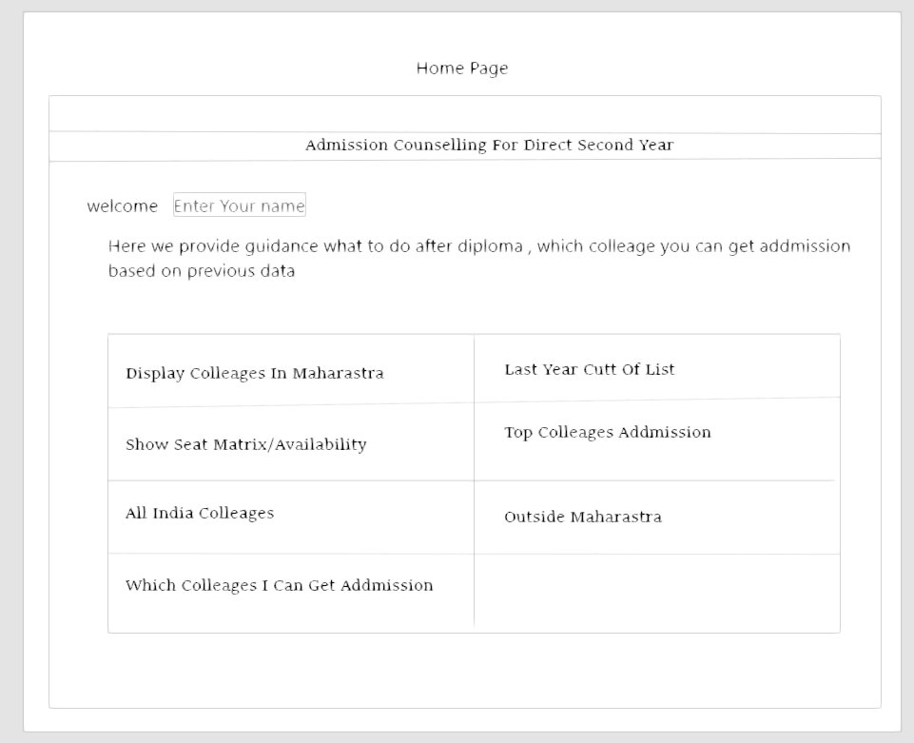

**Resources and Consumables Required:**

**Hardware Resources**

This has to do with the basic hardware the system needs to possess for optimum performance and includes system unit with the following configuration:

1. 20 MB of Memory
2. 512 Ram
3. Internet Connection

**Software Resources**

For effective functioning of this software, there is a software platform required to run on the system. This software tool acts as a platform for the new system to work.

|  |  |
| --- | --- |
| Date | Description |
| 1-08-2019 to 8-08-2019 | We decide the project topic |
| 12-08-2019 to 19-08-2019 | We discuss with team members |
| 21-08-2019 to 28-08-2019 | Search information on topic |
| 3-09-2019 to 10-09-2019 | Read articles on topic |
| 12-09-2019 to 19-09-2019 | Select language for topic |
| 1-01-2020 to 8-01-2020 | We will create a Where I Can Get Admission module |
| 10-01-2020 to 17-01-2020 | We will create a All India Colleges module |
| 20-01-2020 to 27-01-2020 | We will create a Cut Off List module |
| 3-02-2020 to 10-02-2020 | We will create a Display Colleges In Maharashtra module |
| 13-02-2020 to 20-02-2020 | We will create a Outside Maharashtra College module |
| 2-03-2020 to 9-03-2020 | We will check if the module is working over a network |
| 11-03-2020 to 18-03-2020 | We will test the modules. |

**Action Plan:**

**References:**

1. Quora.com.
2. dse19.mahacet.org.in.